Fake Server Framework for Windows Mobile

Contents
Contents 2
1 Introduction 3
1.1 Testing the device web application 3
1.2 Issues with the test architecture 4
1.3 Alternate Test Application Architecture 4
1.4 Dependencies 5
1.5 Terminology 5
2 High-Level Architecture 7
2.1 Components of the fake Server Library 7
2.2 How does it all work? 8
2.3 Managed fake server applications using Callbacks 9
2.4 Managed fake server applications using Response Queues 9
2.5 Important Note about the Callbacks & Response Queues 9
3 Detailed Design 9
3.1 Microsoft.WindowsMobile.Samples.FakeServer.dll 9
3.1.1 FakeServer class 10
3.1.2 FakeResponse class 11
3.1.3 FakeResponseQueue class 11
4 Appendix 11

Introduction
This document details the design of the fake Server framework for Mobile Devices. There are many CE services and applications that use the TCP/IP networking stack to talk to external servers on the internet/intranet. For e.g. a on device weather reporting service, a stock reporting service, applications like pocket IE etc. Developing automated tests for such services has often been challenging due to networking dependencies, lack of control over the server environment and the lack of a library that encapsulates the networking functionality needed for such tests.
Let’s look at a sample web application that talks to a web server sitting on the internet and talk about how we would go about testing it etc.

Let’s take the case that you are developing a device application that gathers stock quotes from a server and displays them on the device. Your application is typically composed of a set of core APIS (call them Client Application API) that gather the stock quote from a server and a UI framework that renders the stock quote information on the device. The Client Application API would either use the networking layer directly through sockets or indirectly (via WININET or .NET CF libraries) to talk to the stock quote web server on the internet.

Testing the device web application
Now if you are asked to test this application your tests would consist of API level tests and some UI tests. Your high level test application architecture would look something like this

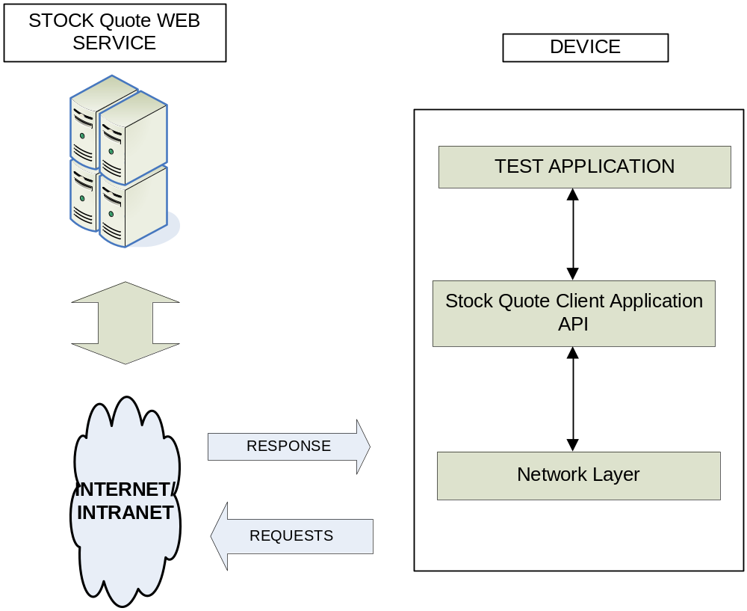

Issues with the test architecture
There are a few issues with this model

1. You need internet connectivity at all times to run the tests.
2. You would need a dedicated server running the web server at all times.
3. Due to the server dependency, your device will not be able to run stand alone tests.
4. Dependency on an external server can introduce multiple points of failure in your tests. For example if the server is down all your tests will fail or if there is a firewall blocking connections then the tests will fail as well etc.
5. Lack of programmatic control over the server environment. For example you cannot force the web server to send down malformed responses to test how your device application behaves etc.
6. In many case, the web server code will be developed in parallel to the web client (the device code). In such cases it won’t be possible to test the client side of the code till the server side code is fully developed. This can be a big blocker and prevent testing till the very end.

Alternate Test Application Architecture
The fake server library was developed to address the above issues. Let’s say that there was an easy way to develop a light weight ‘test’ stock quote web server that ran on your device itself. Then our client application (i.e the application under test in this case the stock quote application) could talk to the stock quote web server that runs on the device!

If we could accomplish that our tests would not have any external server dependency or any connectivity dependency. The tests could be run stand alone! Furthur more imagine if we could send down any response to our device application. That could open up infinite possibilities to test our device application in a bullet proof manner.

The fake server library allows you to do exactly these above things in a very easy and a clean fashion. Using the fake server library you can develop your ‘test’ stock quote service that runs on the device. The service will be ruinning on the Loop Back interface on the device (IP address: 127.0.0.1) and will be started on port 80. Please close any applications that run on that port for e.g. on device IIS server. In most cases port 80 is readily available. The test service can be programmed to send back any response you intend. For e.g. the stock quote service could send back a response similar to the web server response from a real web server.

In just a few lines of code you can have your very own ‘test’ stock quote service to test your client application. The possibilities are further expanded by the fact that you have complete control over your ‘test’ service, and as an added bonus you don’t need any connectivity dependency to test your device application!

All you need to do is
- Develop the test stock quote service that runs locally on the device. Can be done under 10 lines of managed code using the fake server library
- Set up your application to send stock quote requests to the loop back address (IP: 127.0.0.1) at port 80 where the test quote service is running.

The test application architecture now looks like this.

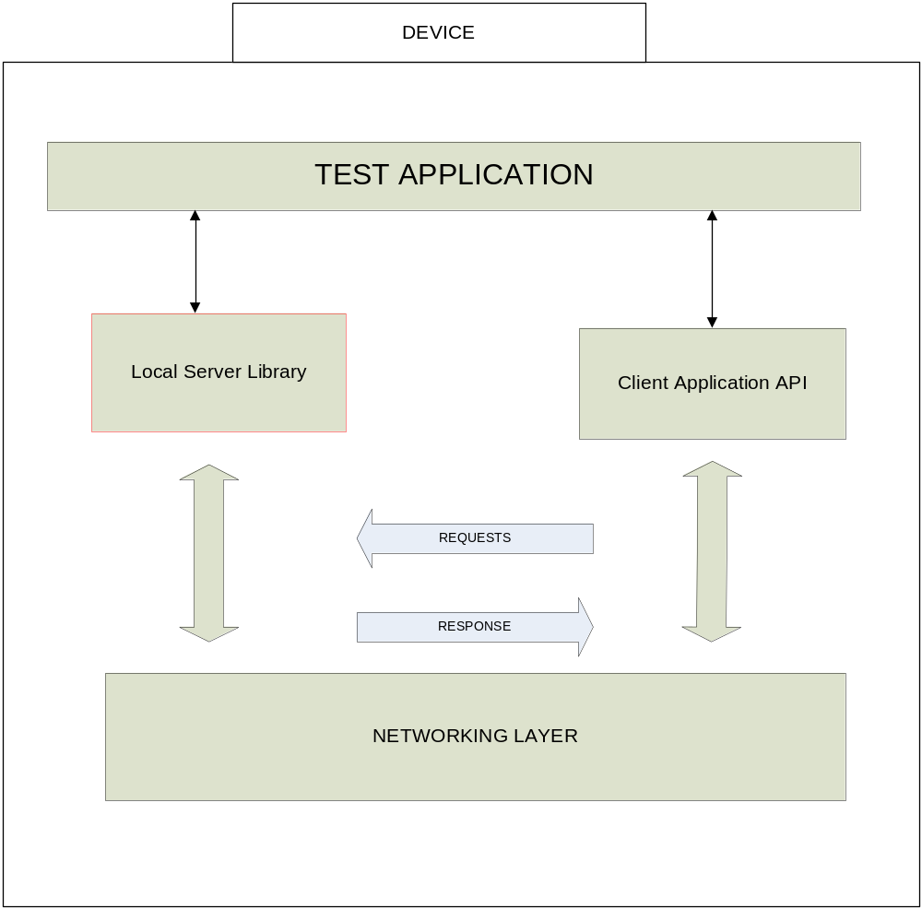

Dependencies
The framework needs NET CF 2.0 to be installed on the device. There are no external dependencies besides this.

Terminology
Loopback | Local host interface on the device
Socket | Winsock sockets on CE
.NET CF 2.0 | DotNet Compact Framework 2.0
Native Code | C++
Managed Code | C#

High-Level Architecture
The fake server framework can be used by developers to write custom server applications that run on the device itself. These applications are very simple to write using the fake server library (as we can see you can write your own in less than 10 lines of code!). Before we go ahead with the design details lets have a look at a high level architecture.

In the sections below we detail the architecture diagram of the fake Server library & also a component diagram explaining the various pieces.

Components of the fake Server Library
The framework is broadly composed of managed and native components built on top of windows sockets. The components are as follows

FakeServer.dll
This is a native C++ DLL built directly on top of windows sockets. This DLL contains the complete implementation of the fake Server Library. This has the logic for receiving a connection and handling the exchange of data between the server and the client application.

Microsoft.WindowsMobile.Samples.FakeServer.dll
This is the managed DLL built on top of fakeserver.dll. It has well defined interfaces to start a server thread on port 80 on the device (ofcourse the port should not be in use). The interfaces also implement the ability to handle data received from the client and send response data back to the client. Test Applications can exchange data with their clients using managed callbacks or using response queues. We will look at the two methods in detail in the sections to follow.

So over all 2 types of test applications can be built using the fake server library.

Type1: Managed Test Server Applications using callbacks
Type2: Managed Test server applications using request queues.

More on both of these types of applications later, but for now diagrammatically the modules appear like this.

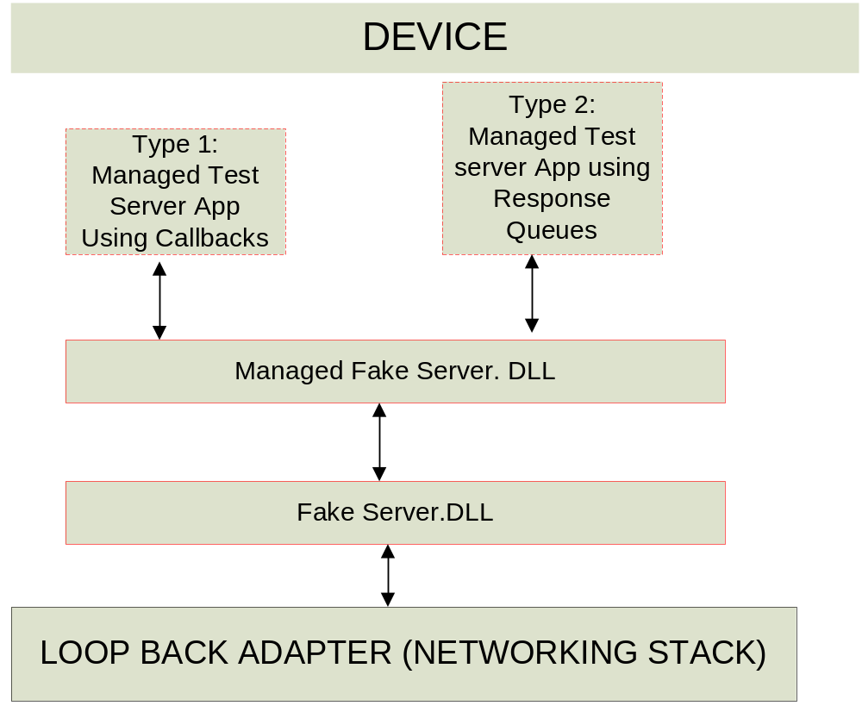

How does it all work?
In this section we will provide details on the inner working of fake server library and the interaction between the native and the managed components.

The managed fake server DLL loads up the native (C++) fakeserver.DLL and requests it to start a server thread on the device’s local host interface (IP:127.0.0.1) on port 80.

Let’s assume that the test application has request that the server thread listen on port 80. Now when a TCP connection is made to 127.0.0.1 port 80, the server thread accepts the connection and waits for the client to send data over the connection. Once the data arrives, the Native (C++) fakeserver.DLL calls into the Managed fake server DLL (Microsoft.WindowsMobile.Samples.FakeServer.DLL) with the data that was received over the connection. The managed DLL then either reads the responses to be sent from a response queue or invokes a callback into the test application requesting it to supply the response that it wants to send back. Once the response is generated, the managed DLL sends the response to the native DLL which sends it back to the client application.

The server framework is protocol agnostic, the server application built on top of the framework is responsible for generating the right response to be sent to the caller.

Managed fake server applications using Callbacks
As we mentioned in section 3.1, the managed library provides two methods to the test application to exchange data with the clients. In this section we will discuss the callback approach. The callback approach is ideal for test server applications who want to send responses to their client application (i.e the application under test) depending on the request that they received. If you use the callback approach, you will be able to see the data that was sent by your client application (i.e the application under test). Based on the client request you may choose the response you need to send.

Managed fake server applications using Response Queues
As we mentioned in section 3.1, the managed library provides two methods to the test application to exchange data with the clients. In this section we will discuss the response queue approach. The response queue approach is ideal for test server applications that need to send a certain set of responses in sequence to the client application (Ii.e. the application under test). For e.g. if you know before hand that you need to send a set of invalid responses to every request the client (the application under test) ever made, then you could add such responses to the response queue and not worry about callbacks or anything. The managed framework will send out the responses in the order you added them to the response queue.

There is also another special queue called the default response queue. Say you added a set of responses to the response queue and your test server sent all of them out, in this case the managed library turns to the default response queue. This is a queue of one or more default responses that need to be sent when the response queue is EMPTY. This queue is special in the fact that it is a circular queue, if add say 3 responses (call it R1, R2, R3) to the default response queue, the managed library will send out the responses in order R1, R2, R3, R1, R2, R3 …

Important Note about the Callbacks & Response Queues
It’s important to note that the two approaches to exchange data with the client are completely exclusive. You cannot and should not mix or match both of them. For e.g. don’t set a callback function and also add responses to the response queue at the same time. OR for that matter don’t add responses to the response queue and set the callback function later.

Pick one of the two supported data exchange mechanisms and stick to it. The behavior of the fake server library is undefined if you attempt to mix and match the two approaches.

Detailed Design
In the sections below we will discuss the interfaces exposed by Microsoft.WindowsMobile.Samples.FakeServer.DLL in greater detail.

Microsoft.WindowsMobile.Samples.FakeServer.dll
This is a managed dll that acts as a wrapper for FakeServer.dll. Its functionality can be broken down into the following areas:
- Imports the methods that are exported by FakeServer.dll to control the server (like init, start, stop, etc) and exposes them as static methods of FakeServer class
- Provides a managed class – FakeResponse that represents a response that tests might want to send back to the client application.
- Test applications using this dll can register their own callback function (using the FakeServerRequestCallback delegate) that will be called everytime the server receives a request. This can be used to test applications that need to read the request arriving at the server before deciding what response to send. Please refer to section 3.3 for more details.
- The dll exposes a ResponseQueue – This queue can be used by tests if they know the responses that need to be sent back to the client. If you choose the ResponseQueue (from the application that is being tested). Please refer to section 3.4 for more details.
- The dll also exposes a DefaultResponses list – This is a rolling list that is used when the ResponseQueue is empty. Please refer to section 3.4 for more details.

FakeServer class

Initialize()
Initializes the server to listen on port 80

InitializeEx(string pbPortNum, Int32 fSecure, string pbCertPath, string pbCertPwd, FakeServerRequestCallback pfnRequestCallback)
Initializes the server with the following parameters
pbPortNum The port number that the service needs to be started on
fSecure This parameter MUST always be 0.
pbCertPath Not used, MUST Be null
pbCertPwd Not used MUST be NULL
pfnRequestCallback User defined call back function

Start()
Starts the server. Now the server will start listening at the port for requests.

Stop()
Stops the server from listening for requests.

SetRequestCallback(FakeServerRequestCallback)
Registers a callback function that will be called eveytime the server receives a request. This will override the ResponseQueue and DefaultResponse functionality.

ResponseQueue (PROPERTY)
This is a queue of FakeResponse objects used when no callback function is registered. When the server receives a request and this queue is not empty, then it dequeues a response off this queue and sends that to the client.

DefaultResponses (PROPERTY)
This is used by the server when the ResponseQueue is empty. This is a rolling list of responses. When the end is reached, the server starts looking at this list from the beginning.

FakeResponse class

FakeResponse()
Empty constructor

FakeResponse(byte[])
Constructor that accepts a byte array to initialize the object.

Bytes (PROPERTY)
Gets and Sets the array of bytes that representing the FakeResponse object.

FakeResponseQueue class

FakeResponseQueue()
Empty constructor

Enqueue(FakeResponse)
Adds a reponse to the queue at the end.

Dequeue()
Dequeues a response off the queue

Appendix
Sample applications built on top of the fake server are shipped with the SDK. Please download the windows mobile SDK for referring to such samples.

